Things to know:
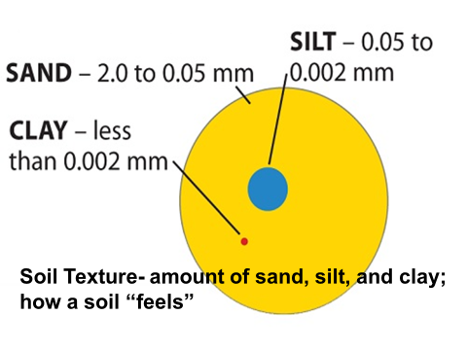
Available water capacity is the volume of water that should be available to plants if the soil, inclusive of fragments, were at field capacity. It is commonly estimated as the amount of water held between field capacity and wilting point, with corrections for salinity, fragments, and rooting depth. Available water capacity is an important soil property in developing water budgets, predicting droughtiness, designing and operating irrigation systems, designing drainage systems, protecting water resources, and predicting yields.
Example to figure AWC.
Elliott soil had a rooting depth to 60 inches. What is the AWC 0 to 60 inches?
Horizon horizon depth (inches) texture AWC (in/in of the soil)
A1 0-10 sil .23 .23x10=2.3
A2 10-14 sicl .22 .22x4=.88
Bt1 14-30 sic .12 .12x16=1.92
Bt2 30-36 sicl .19 .19x6=1.14
C 36-60 sicl .19 .19x24=4.56
____________
10.8 inches
Saturated hydraulic conductivity (old term-permeability) is the ease with which pores of a saturated soil transmit water. Formally, it is the proportionality coefficient that expresses the relationship of the rate of water movement to hydraulic gradient in Darcy's Law (a law that describes the rate of water movement through porous media). It is expressed in micrometers per second. To convert micrometers per second to inches per hour, multiply micrometers per second by 0.1417. The historical definition of “saturated hydraulic conductivity” is the amount of water that would move vertically through a unit area of saturated soil in unit time under unit hydraulic gradient. Saturated hydraulic conductivity is used in soil interpretations. It is also known as K_{sat}. The soil properties that affect saturated hydraulic conductivity are distribution, continuity, size, and shape of pores. Since the pore geometry of a soil is not readily observable or measurable, observable properties related to pore geometry are used to make estimates of saturated hydraulic conductivity. These properties are texture, structure, pore size, density, organic matter content, and mineralogy.

Landform information
Some common landforms in eastern CO:
Fluvial: floodplain, floodplain step, stream terrace, drainageway
Eolian: dune, sand sheet, blowout
Slope: interfluves, hillslope, mountain slope
Erosional: pediment
Depressional: playa, closed depression, drainageway
Some common Landscapes in eastern CO: plains, mountains

Aspect: direction toward which a slope faces with respect to the compass or the rays of the sun (south facing/ north facing)

Review slides 7, 10, 11, 17, 21, and 42 on the Intro to Soils 2017lc.pptx power point

